(Approx. 511 words)

Continuous Ink Supply System (CISS or CIS)
By David Kazmer, Member, SCV Computer Club, California
February 2016 issue, Dataline
www.scvcomputerclub.org
scvcomputerclub (at) gmail.com

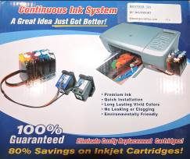
There is an old marketing strategy of “Give them the printer and sell them the ink” that is starting to be challenged by alternate methods of using inks. The transition between ink cartridges and imbedded ink printers (described later) is the Continuous Ink Supply system. There are many of these on the market and each is designed for a particular make, model, and technology of printer. Not all printers have a CIS made for them. Most are by third-party manufacturers but a few are starting to be made by the printer OEM’s as they are finally recognizing the demands of the public.

Basically, the systems consist of larger ink storage containers external to the printer which should be easy to access for adding bulk ink; a delivery system sometimes including small hose sets; and hardware to fool the printer into thinking that you are using the correct (smaller) OEM ink cartridges.

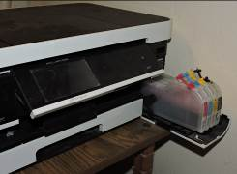
I have had a CIS for my Brother printer for nearly two years and after the initial slightly awkward installation the system has been running just fine. This system uses extra large cartridges that extend out of the ink cartridge compartment, beyond the front of the printer and have refill openings (plugged) on the top, which are reasonably easy to access. The cartridges are designed to plug directly into the printer ink slots and the mechanism to fool the printer into thinking that I am using OEM ink is a small curved piece of plastic to trip the ink door sensor. If the door is detected as being open, the printer will not work. The installation comes with detailed and illustrated instructions.

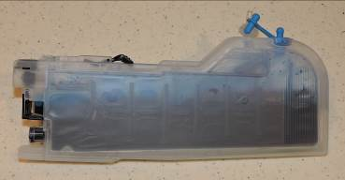
Adding bulk ink is very easy and lasts so long that I almost forget to check the level, maybe monthly. The CIS manufacturer suggests to keep the ink level over one third full just to avoid any sensor problems. I now buy Brother-compatible ink in bulk and save money. I purchased a box set of four colors of bulk ink and have only needed to add ink rarely. After about two years I still have most of the ink. The bulk ink can also be bought one color at a time, to suit your needs. In any case you should be very careful when handling bulk ink supplies. Mistakes can have disastrous potential, so thin rubber gloves, lots of newspaper, and a roll of paper towels are suggested for first-time users.

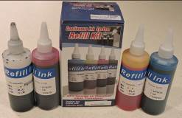
The market for printers is headed away from cartridges and toward imbedded ink supplies, which is simply an OEM built-in method of using bulk ink in the printer. Epson was the first manufacturer to produce a model, with HP also getting into the market. Brother has just released their own model in India, but not yet available in the U.S. The technology is still leading-edge. The prices for embedded-ink printers are presently slightly higher than standard models, but we should have been expecting that.

